Anzac Biscuit Art

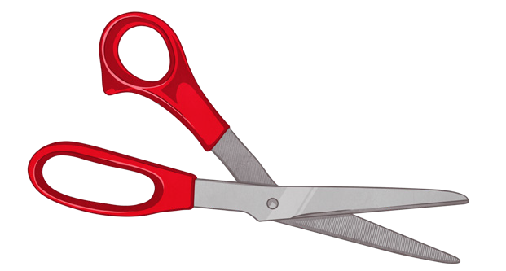
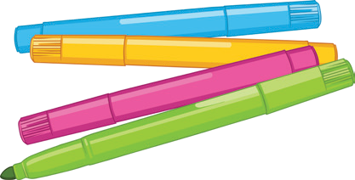
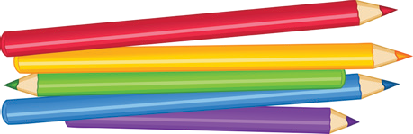
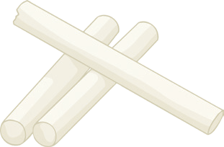
You will need:
A3 paper (for the background) A4 paper (for face and biscuits) Scissors
Glue sticks
Media for drawing (pastels, crayons, felt tip pens, coloured pencils)

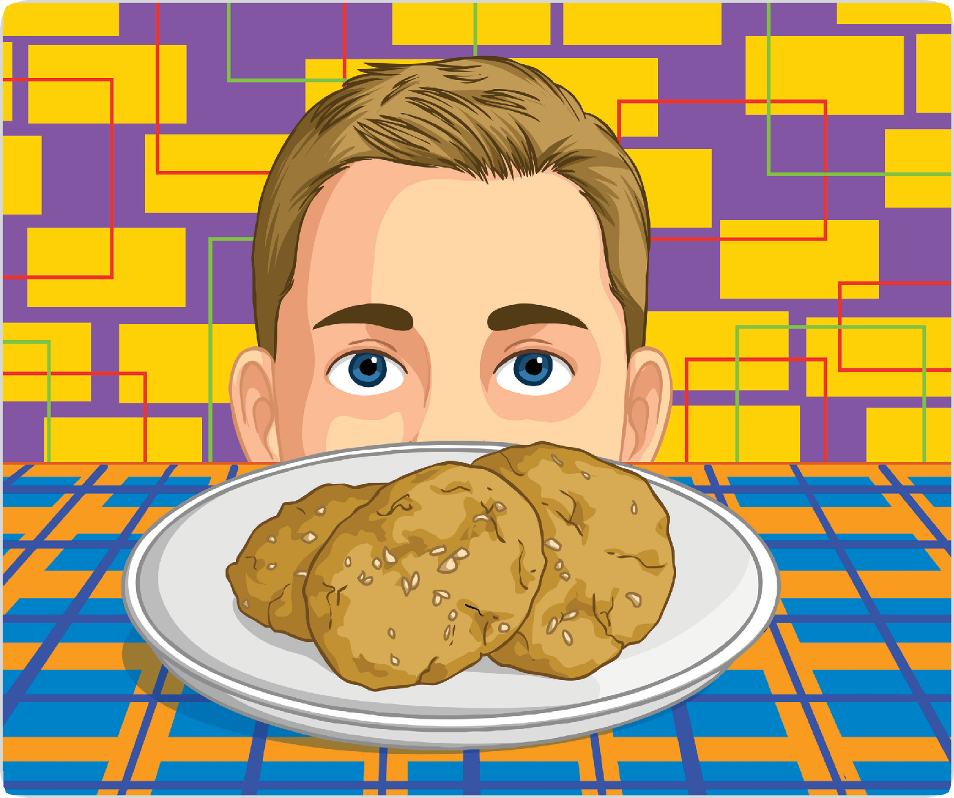

Instructions
Background:
- Using a pencil, rule a line across the page just below half way.
Anzac Biscuit Art
- The bottom section of the page is going to represent a tablecloth.
- On this section, draw a plate shape for the cookies to be added to later.
- Using a pencil, draw a simple pattern to cover the rest of the tablecloth section.
- Colour the tablecloth pattern using two complementary colours.
- For the top section of the page, choose a different pattern and then colour using two different complementary colours.
- Add Anzac biscuits to the plate. These could be drawn on or a photo of biscuits made in class could be enlarged, cut out and glued on to add a different textural element to the artwork.
- Leave the rest of the plate white or colour it in.
Face:
- Using a separate piece of A4 sized paper, fold and then cut in half.
- One can be used as a draft piece (to see if you have the head size right, the features in proportion etc.)
- When you have finished your draft, use the other piece of paper to redraw the top part of your face from your hair down to the bridge of your nose.
- Consider which colours will work best to create a realistic skin tone, hair and eye colour before colouring.
- Carefully cut out the half-head shape and line it up with the tablecloth section before glueing it on, creating the illusion of a face peering over the table at the biscuits.
- Your Anzac biscuit art will then be complete.

Anzac Biscuit Art

Complementary Colours
When you look at a colour wheel, complementary colours are ones that are opposites on the colour wheel. For instance, purple and yellow are complementary colours. You might notice that complementary colour pairs are made up of one warm colour (oranges, reds and yellows) and one cool colour (blues, greens and purples). Combining a cool colour and a warm colour creates a vibrant and eye-catching contrast.

Purple

Purple-Red
(Tertiary)
Red

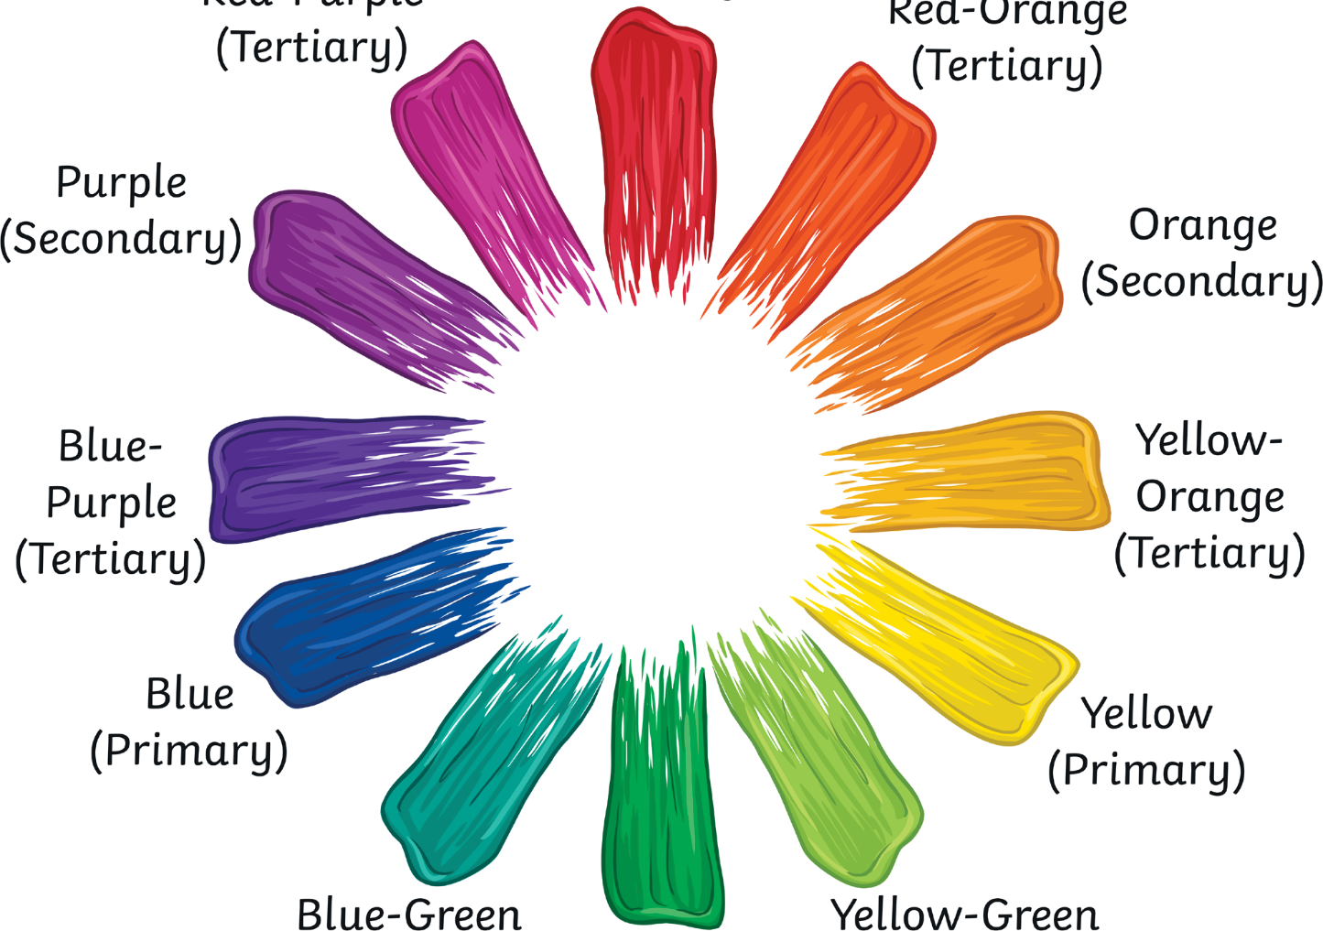
(Primary) Red-Orange
(Tertiary)

Orange

(Secondary)

Blue-Purple
(Tertiary)

Blue
(Primary)
(Secondary)

Yellow-Orange
(Tertiary)

Yellow
(Primary)

Blue-Green
(Tertiary)

Green
(Secondary)
Yellow-Green
(Tertiary)

